**Chapter 4 - Nothing Is Impossible - The Construction of Spectacular Brooklyn Bridge**

**All Lectures Uploaded on YouTube:** [**https://tinyurl.com/fkm9-english**](https://tinyurl.com/fkm9-english)

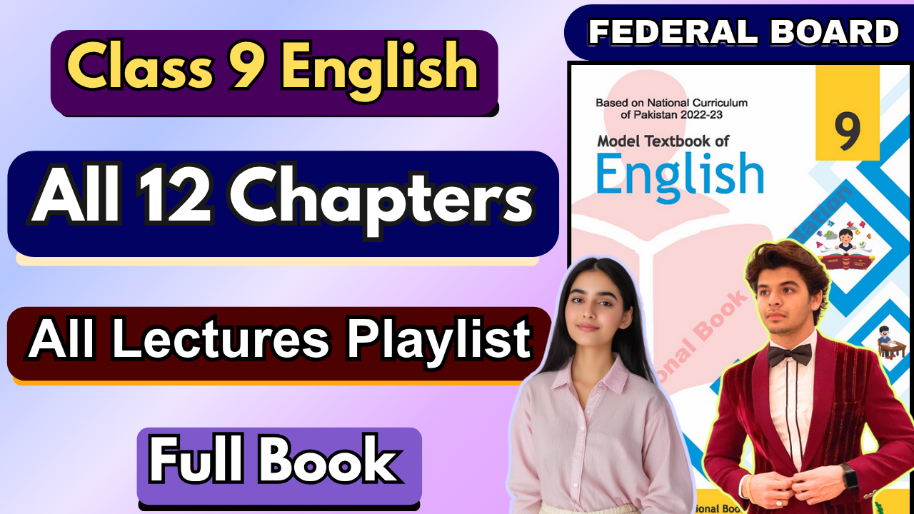

**Question/Answers**

# 1. What was the dream of John Roebling?

**Ans.** John Roebling's dream was to build a spectacular bridge connecting New York with Long Island.

# 2. What had happened when the project was underway?

**Ans.** During the project, John Roebling had a tragic accident that led to his death, and his son Washington Roebling, who took over, later suffered from decompression sickness, which left him paralyzed and unable to move or speak.

# 3. Why did the people criticize the Roeblings?

**Ans.** People criticized the Roeblings because they thought the project was impossible and foolish, calling them "crazy men with crazy dreams" and suggesting that the bridge could not be completed without the Roeblings' direct involvement.

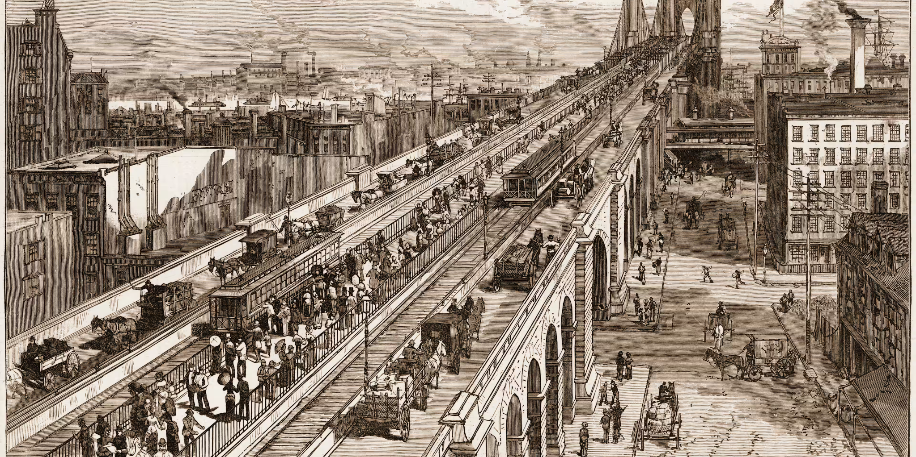

# 4. Which disease attacked the underwater workers, and what were its symptoms?

**Ans.** The underwater workers, including Washington Roebling, suffered from decompression sickness, known as "caisson disease," which caused paralysis and other serious health issues.

# 5. How did Mr. Washington communicate after the tragic accident?

**Ans.** Washington communicated by tapping his finger on his wife Emily's arm, using a code they developed together, allowing him to pass instructions to the engineers through her.

# 6. Who was Emily Warren Roebling, and what role did she play in the execution of the project? Ans. Emily Warren Roebling was Washington Roebling's wife. She played a crucial role by acting as the intermediary between Washington and the engineers, managing much of the bridge's construction and studying bridge engineering to assist with technical tasks.

# 7. Explain "When there is a will, there is a way," in the light of the given lesson.

**Ans.** The story of the Brooklyn Bridge exemplifies the saying "When there is a will, there is a way." Despite numerous challenges, including both John and Washington Roebling's incapacitating injuries, Washington's determination and Emily's dedication allowed the bridge project to continue. Their perseverance and resourcefulness made the seemingly impossible task a reality.

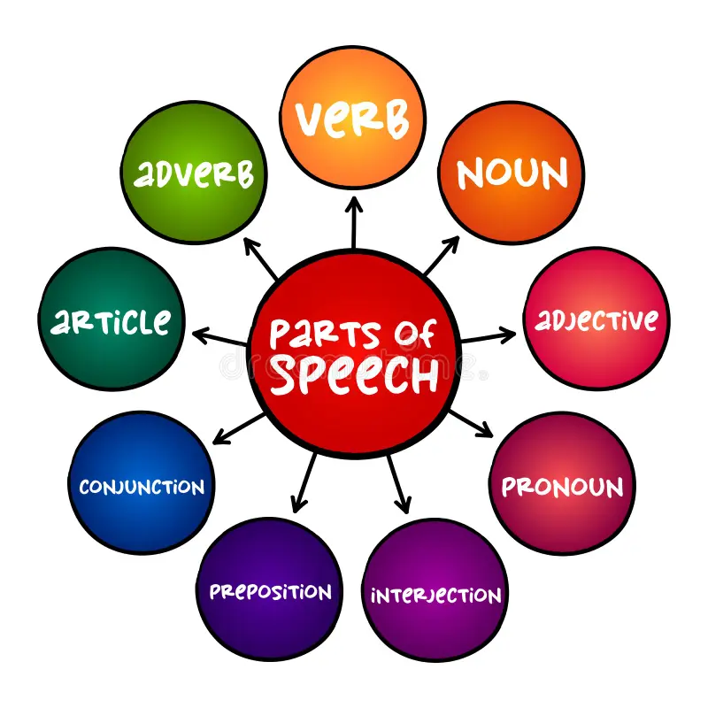

**Parts of Speech**

# Nouns

* + **Definition**: Nouns are words that name people, places, things, or ideas.

# Types of Nouns:

* + - **Common Nouns**: General names (e.g., *city, book*).
    - **Proper Nouns**: Specific names, always capitalized (e.g., *Paris, Shakespeare*).

# Pronouns

* + **Definition**: Pronouns replace nouns to avoid repetition.
  + **Example:** He, she, it, I

# Verbs

* + **Definition**: Verbs express actions, events, or states of being.
  + **Example:** dancing, running

# Adjectives

* + **Definition**: Adjectives describe or modify nouns or pronouns.
  + **Examples**: *happy, blue, large, interesting*.

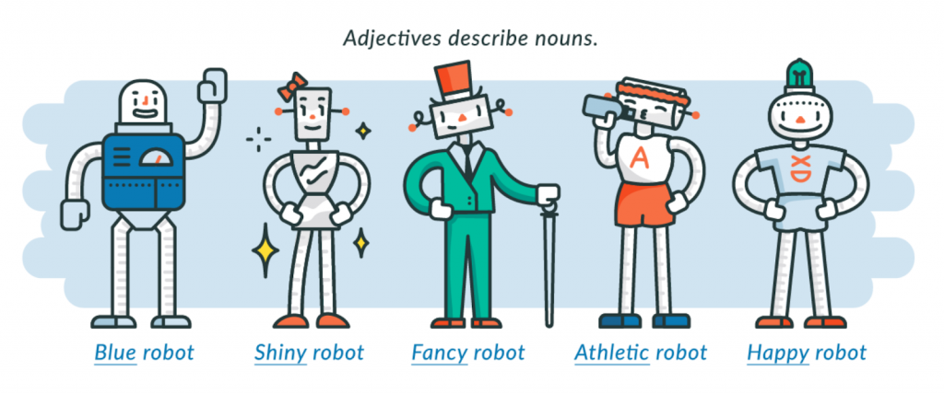

# Adverbs

* + **Definition**: Adverbs modify verbs, adjectives, or other adverbs and often end in “-ly.”

# Types of Adverbs:

* + - **Manner**: How something is done (e.g., *quickly, softly*).
    - **Place**: Where something happens (e.g., *here, outside*).
    - **Time**: When something happens (e.g., *now, yesterday*).
    - **Frequency**: How often something happens (e.g., *often, rarely*).
    - **Degree**: The intensity of an action (e.g., *very, quite*).

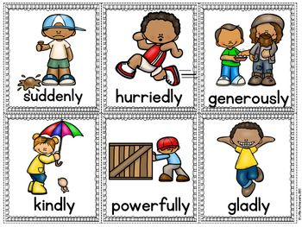

**6. Prepositions**

* + **Definition**: Prepositions show the relationship of a noun or pronoun to another word.
  + **Examples**: *in, on, under, between, during*.

# Types of Prepositions:

* + - **Time**: Indicate time (e.g., *at, during, since*).
    - **Place**: Indicate location (e.g., *in, on, near*).
    - **Direction**: Indicate movement (e.g., *to, through, towards*).

# Conjunctions

* + **Definition**: Conjunctions connect words, phrases, or clauses.

# Types of Conjunctions:

* + - **Coordinating Conjunctions**: Connect equal parts (e.g., *for, and, nor, but, or, yet, so*).
    - **Subordinating Conjunctions**: Connect a dependent clause to an independent clause (e.g., *because, although, if*).
    - **Correlative Conjunctions**: Work in pairs (e.g., *either…or, neither…nor*).

1. **Interjections**
   * **Definition**: Interjections are words or phrases that express strong emotion or surprise.
   * **Examples**: *Wow! Oh! Ouch! Hurray!*

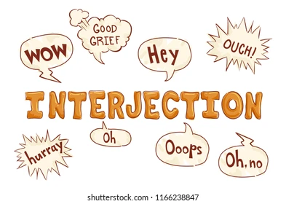

# 9. Determiners

* + **Definition**: Determiners clarify nouns by specifying which one or how many.

# Types of Determiners:

* + - **Articles**: (e.g., *a, an, the*).

**Q: Identify the part of speech of the highlighted word in each sentence.**

1. He runs ***fast*.**
   * **Part of Speech**: *Adverb* (describes how he runs)
2. The geese ***indolently*** waddled across the intersection.
   * **Part of Speech**: *Adverb* (describes how the geese waddled)
3. **Yikes!** I’m late for class.
   * **Part of Speech**: *Interjection* (expresses surprise or alarm)
4. Bruno’s ***shabby*** thesaurus tumbled out of the book bag when the bus suddenly pulled out into traffic.
   * **Part of Speech**: *Adjective* (describes the thesaurus)
5. Mr. Frederick angrily ***stamped*** out the fire that the local hooligans had started on his verandah.
   * **Part of Speech**: *Verb* (shows the action he performed)
6. He **is** a *fast* runner.
   * **Part of Speech**: *Adjective* (describes the noun “runner”)
7. Later that summer, she asked herself, **“**What was I thinking ***of*?”**
   * **Part of Speech**: *Preposition* (shows the relationship with “thinking”)
8. She thought that the twenty zucchini plants would ***not*** be enough so she planted another ten.
   * **Part of Speech**: *Adverb* (modifies the verb "be")
9. **Although** she gave hundreds of zucchini away, the enormous mound left over frightened her.
   * **Part of Speech**: *Conjunction* (connects clauses)
10. Everywhere she went, she talked about the ***prolific*** veggies.
    * **Part of Speech**: *Adjective* (describes the noun "veggies")
    * Prolific means vegetables that grow or yield plentiful



